Software Requirement Specification

For

Hospital Management System

Version 1.0 approved

Prepared by:

1. R. Rohit Ramana - (22BD1A6746)

2. K. Rishith - (22BD1A6729)

3. Siddhant Jaiswal - (22BD1A6754)

4. S. Venkatramana - (22BD1A6755)

5. V. Shravan - (22BD1A6763)

# Keshav Memorial Institute of Technology

**25-09-2024**

**Table of Contents**

**Table of Contents ............................................................................................................................2**

**Revision History ..............................................................................................................................3**

1. **Introduction...............................................................................................................................4**
   1. Purpose...............................................................................................................................................
   2. Document Conventions....................................................................................................................
   3. Intended Audience and Reading Suggestions..................................................................................
   4. Product Scope ..................................................................................................................................
   5. References..........................................................................................................................................
2. **Overall Description ...................................................................................................................6**
   1. Product Perspective............................................................................................................................
   2. Product Functions ..............................................................................................................................
   3. User Classes and Characteristics .......................................................................................................
   4. Operating Environment......................................................................................................................
   5. Design and Implementation Constraints ............................................................................................
   6. User Documentation ..........................................................................................................................
   7. Assumptions and Dependencies ........................................................................................................
3. **External Interface Requirements ............................................................................................8**
   1. User Interfaces ...................................................................................................................................
   2. Hardware Interfaces ...........................................................................................................................
   3. Software Interfaces ............................................................................................................................
   4. Communications Interfaces ...............................................................................................................
4. **System Features ........................................................................................................................9**
   1. Patient Registration............................................................................................................................
   2. Doctor Management.........................................................................................................................
   3. Appointment Scheduling.............................................................................................................
   4. Billing and Payment.....................................................................................................................
   5. Reporting......................................................................................................................................
5. **Other Nonfunctional Requirements.......................................................................................11**
   1. Performance Requirements................................................................................................................
   2. Safety Requirements ..........................................................................................................................
   3. Security Requirements .......................................................................................................................
   4. Software Quality Attributes ...............................................................................................................
   5. Business Rules ...................................................................................................................................
6. **Other Requirements ................................................................................................................12**

**Appendix A: Glossary....................................................................................................................13**

**Appendix B: Analysis Models .......................................................................................................14**

**Appendix C: To Be Determined List.............................................................................................18**

# Revision History

|  |  |  |  |
| --- | --- | --- | --- |
| **Name** | **Date** | **Reason for changes** | **Version** |
| Week-1 | 25-09-24 | SRS creation(Introduction) | 1.0 |
| Week-2 | 18-10-24 | Use Case Diagram, Templates,  Class diagram | 2.0 |

1. **Introduction**

The Software Requirement Specification is designed to document and describe the

agreement between the customer and developer regarding the specification of the software product

requested.

This documentation is done to provide a clear idea of customer requirements. This document can

be used as reference in further development of the software system.

# Purpose:

The purpose of this SRS is to describe the software requirements for the Hospital Management System (HMS). The HMS will automate patient management, doctor management, appointment scheduling, billing, and reporting. This document outlines the system's functionality and intended use.

# Document Convention:

## Heading:

* Font-Size:16 Font-Style: Bold
* Font: Times New Roman

## Subheading:

## Font-Size:14 Font-Style: Bold

## Font: Times New Roman

## Content:

* Font-Size:12
* Font: Times New Roman.

## Intended Audience and Reading Suggestions:

This document is intended for software developers, project managers, testers, and hospital administration staff. The document begins with a high-level overview of the system, followed by detailed system features and requirements. Developers should focus on Sections 2 and 4, while testers may concentrate on Sections 3 and 5.

## Product Scope:

The Hospital Management System (HMS) is a comprehensive system that automates operations within a hospital, including patient registration, doctor management, appointment scheduling, billing, and report generation. It aims to streamline administrative tasks, improve patient care, and ensure accuracy in billing and reporting.

## References:

* HMS User Interface Guidelines, Version 1.2
* Hospital Data Privacy Act, 2019

# Overall Description

## Product Perspective

The HMS will replace current manual or semi-automated systems in hospitals. It will interact with other systems such as inventory management and laboratory systems and must be easily integrable with electronic health record (EHR) systems for data transfer.

## Product functions

* Patient registration and management
* Doctor information management
* Appointment scheduling
* Billing and payment processing
* Reporting and analytics
* User role management (Admin, Doctor, Nurse, etc.)

## Operating Environment

* Windows/Linux server environment
* Web browser: Chrome, Firefox, Safari
* Database: MySQL/PostgreSQL
* Frontend: HTML5, CSS3, JavaScript (React/Angular

## User Characteristics

* Admin: Manages system settings and user roles.
* Doctors: Access patient records and manage appointments.
* Nurses: Assist in patient management and access patient information.
* Patients: Can book appointments online.
* Billing Staff: Manage billing, payments, and reports.

## Design and Implementation Constraints

* System must comply with local hospital regulations and data privacy laws.
* The system should be built using secure coding practices, especially for handling sensitive patient data.
* The system will use HTTPS protocol for secure data transmission.

## User Documentation

* User manual for Admin, Doctors, and Billing Staff
* Online help for patients (for appointment scheduling)
* Training tutorials

## Assumptions and Dependencies

* The system assumes users will have access to modern web browsers and reliable internet connections.
* Third-party integration for payment gateways may be necessary.

# Specific requirements

## User Interfaces

* Intuitive dashboard for Admins, Doctors, and Billing Staff.
* Patient-friendly interface for online appointment scheduling.
* Reports section with printable and exportable formats (PDF/Excel).

## Hardware Interfaces

* The system will interface with barcode scanners for patient registration.
* Integration with laboratory equipment to fetch diagnostic reports.

## Software Interfaces

* Integration with hospital inventory management system for medication tracking.
* Connection to government health portals for reporting.

## Communications Interfaces

* Email notifications for appointment confirmations and reminders.
* SMS gateway for alerts to patients and doctors.

**4. System Features**

**4.1 Patient Registration**

**4.1.1 Description and Priority**

* Allows patients to register their details into the system for appointment scheduling and hospital visits.
* Priority: High

**4.1.2 Stimulus/Response Sequences**

* Patient enters details.
* System generates a unique patient ID.
* Confirmation message sent to patient via email/SMS.

**4.1.3 Functional Requirements**

* REQ-1: The system must allow patients to register via an online form or at the hospital.
* REQ-2: The system must store patient records securely in the database.

**4.2 Doctor Management**

**4.2.1 Description and Priority**

* Manages doctor profiles, specializations, schedules, and availability.
* Priority: High

**4.2.2 Functional Requirements**

* REQ-3: The system must allow the admin to add, update, or remove doctor profiles.
* REQ-4: Doctors' availability should be updated in real-time for appointment scheduling.

**4.3 Appointment Scheduling**

**4.3.1 Description and Priority**

* Allows patients to schedule, reschedule, or cancel appointments with doctors.
* Priority: High

**4.3.2 Functional Requirements**

* REQ-5: Patients must be able to book appointments through the website.
* REQ-6: The system must prevent double booking by checking doctor's availability.

**4.4 Billing and Payment**

**4.4.1 Description and Priority**

* Manages patient billing, invoicing, and payment processing.
* Priority: Medium

**4.4.2 Functional Requirements**

* REQ-7: The system should calculate bills based on services availed by the patient.
* REQ-8: It must integrate with payment gateways for online payments.

**4.5 Reporting**

**4.5.1 Description and Priority**

* Generates various reports, including patient records, billing, and doctor performance.
* Priority: Medium

**4.5.2 Functional Requirements**

* REQ-9: Admin must be able to generate custom reports in PDF or Excel format.

**5. Other Nonfunctional Requirements**

**5.1 Performance Requirements**

* The system should support up to 1000 concurrent users with no significant performance degradation.
* Page load times must not exceed 3 seconds.

**5.2 Safety Requirements**

* Sensitive patient data must be encrypted both in transit and at rest.
* The system should have a backup mechanism in case of failure.

**5.3 Security Requirements**

* Role-based access control must be enforced.
* User authentication should include multi-factor authentication (MFA) for Admins and Doctors.

**5.4 Software Quality Attributes**

* Availability: 99.9% uptime
* Maintainability: The system should be easy to update with minimal downtime.
* Usability: User interfaces should be intuitive and accessible with minimal training.

**5.5 Business Rules**

* Only authorized personnel can access patient medical records.
* Billing data should be locked after final payment.

**6. Other Requirements**

* The system must support multiple languages.
* Must comply with GDPR and HIPAA regulations for data privacy.

**Appendix A: Glossary**

* **HMS**: Hospital Management System
* **EHR:** Electronic Health Record
* **HIPAA**: Health Insurance Portability and Accountability Act

**Appendix B: Analysis Models**

* Integration with external diagnostic systems (TBD)

**Use Case Diagram:**

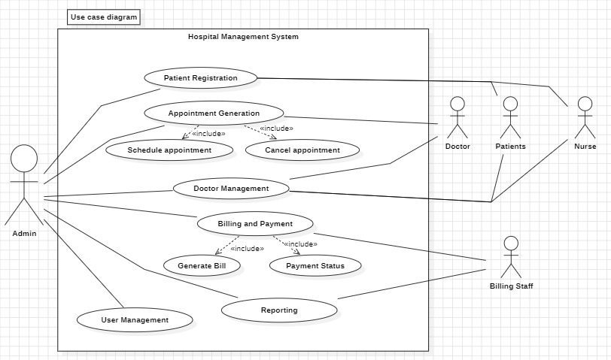

**Use case template**

|  |  |  |  |
| --- | --- | --- | --- |
| **Use Case ID:** | 20241018201 | | |
| **Use Case Name:** | Hospital Management System | | |
| **End Objective:** | Enable hospital staff to manage patient registrations, appointments, billing, and reporting efficiently, ensuring smooth operations. | | |
| **Created by:** | 1. Rohit  2. Siddhant  3. Rishith  4. Shravan  5. Venkatramana | **On (date):** | October 18,2024 |
| **User/Actor:** | Admin, Doctor, Nurse, Patients, Billing Staff | | |
| **Trigger:** | User interaction with the hospital management system for patient, appointment, and billing management. | | |
| **Basic/Normal Flows** | | | |
| **User Actions** | **System Actions** | | |
| Admin logs into the system  Admin registers a patient  Admin schedules an appointment  Admin generates a bill  Admin checks payment status  Admin manages doctor availability  Admin generates reports | System authenticates and grants access based on roles   |  | | --- | |  |  |  | | --- | | System creates and stores the patient record |   System saves the appointment and notifies the patient   |  | | --- | |  |  |  | | --- | | System calculates charges and generates a bill |   System retrieves payment details and shows status  System updates doctor records and availability   |  | | --- | |  |  |  | | --- | | System compiles and displays requested data reports | | | |

**Class Diagram:**

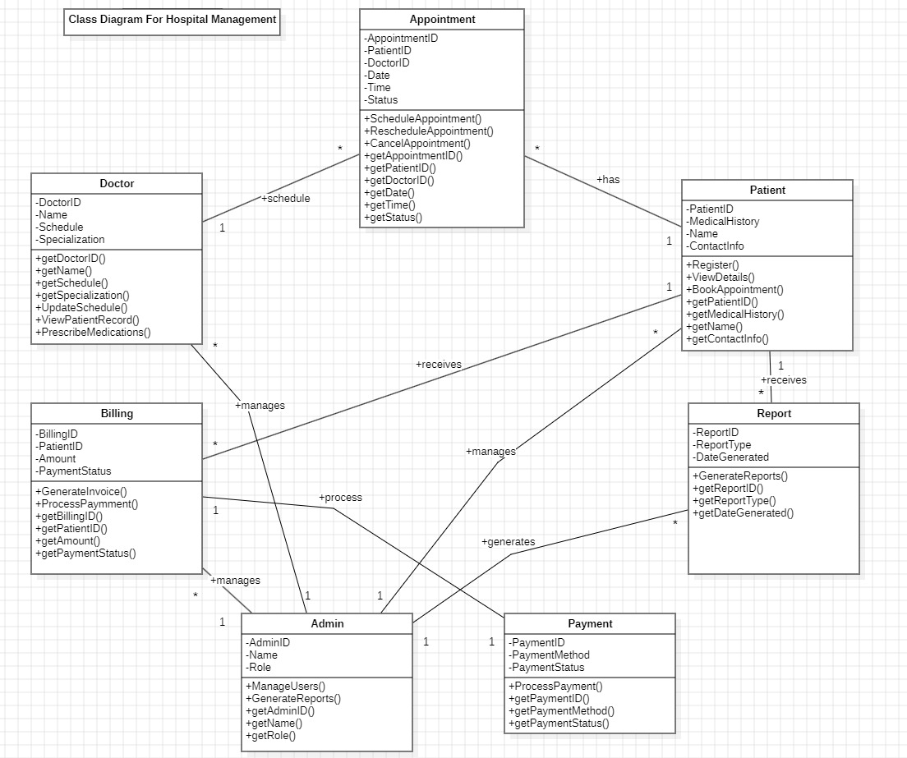

**Appendix C: To be Determined List**